AGREEMENT

Dear

I hope this letter will find you well.

As we gradually move towards the conclusion of our negotiations, perhaps it's time to think about the question of commissions.

On this matter, we would like to anticipate this by signing a mutual agreement. If you agree, you will find attached to this letter an NCNDA non circumvention which you can read and sign at your discretion.

Sir, this document will be part of the set of documents exchanged between you (the Buyer) and the Supplier. It must, therefore, include accurate information, your signature and a copy of your passport.

We are very happy to do business with you. We look forward to a long-term relationship.

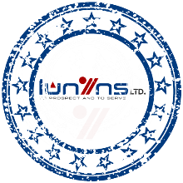

Dear friend, as part of our discussions with certain buyers, we'd like to clarify a couple of aspects with you.

One of our suppliers with whom we have successfully worked in the past is based in Singapore, so we need to comply with official requirements to move forward.

If you don't mind, could you please provide us with the following documents:

1. Certificate of Registration of Legal Entity / Corporate Body
2. Certificate of Tax Registration
3. Article of Association or/ Memorandum of Association
4. Extract from Russian State Register of Legal Entities
5. Information Letter from Russian Federal Agency of statistics
6. Licenses (if any)
7. Copy of passport of the director of Company

Thank you very much. If you need anything else, feel free to com e back to us, we will be happy to help.

Best regards
LUBAMBU TSHILOMBO
Director
